Geo-FS Blue Angels manual

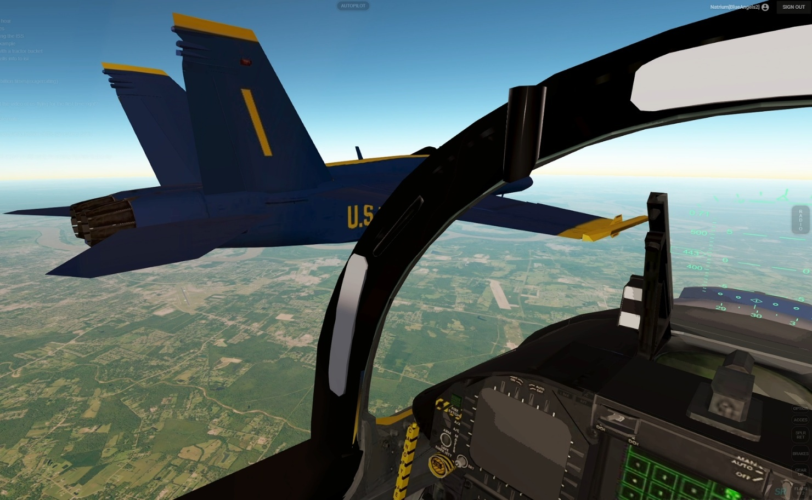

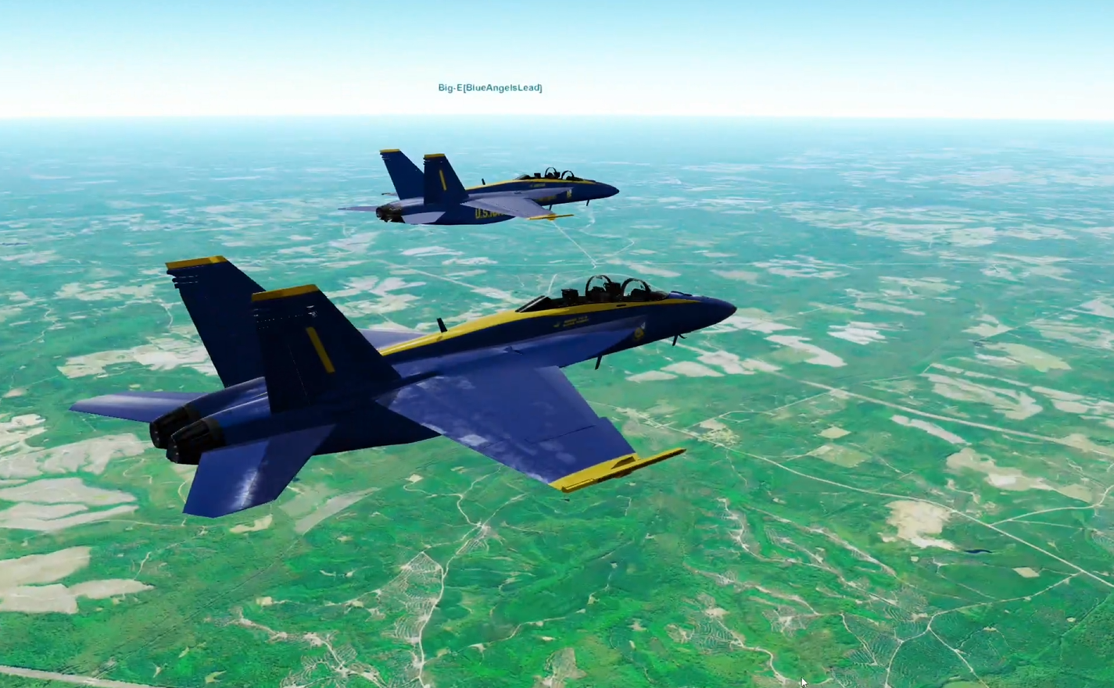

# Introduction

This is the manual for the Geo-FS Blue Angels display team. It contains our procedures and way of working. It’s important to know that this manual is adapted to Geo-FS and our team, and will not always resemble real life procedures. It’s also a work in progress, and will evolve as the team evolves.

Contents

1 Introduction 2

2 Joining the Blue Angels 2

3 Set up your GeoFS simulator 3

4 Communication 6

5 Our training location 7

6 Basic maneuvers 9

7 Formations 16

8 Acrobatics 20

9 Flight Plans 21

# Joining the Blue Angels

**What we are:** a serious group of online pilots who strive to improve our formation flying with every flight. We expect professional discourse. You don’t have to be a pilot in real life.

**What we are not:** gamers who like to instantly *be* without putting in the effort to practise and learn.

Our squadron consists of two groups: *Trainees* and *Pilots*. Trainees aspire to become pilots.

## Prerequisites

In order to become a pilot, you must be able to:

* Manually fly in a coordinated formation at close proximity for extended periods of time;
* Perform basic turns and loops while maintaining the formation;
* Control the F/A-18 during all phases of flight, following the procedures in this manual.

## Pilot check ride

Demonstrate your skills in the Pilot Check Ride. See the chapter with Flight plans. The instructor flying with the trainee assesses your skills, and writes a recommendation to #1, who decides whether to promote you to the status of Pilot.

# Set up your GeoFS simulator

## Joystick

If possible, use a joystick. This allows precise control input and allows you to quickly and precisely centre the flight controls. The hat button allows you to look around while continuing to steer the plane.

The default setting of the F-18 is far too sensitive, allowing for totally unrealistic flight movements, and decreasing your precision. Set the sensitivity to 0.8 for a balance of precision and being able to make quick input changes. Also: do NOT mix Roll/Yaw input:

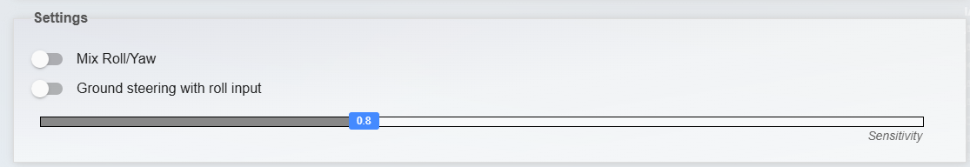

The most important buttons to have on your joystick (preferably on the top of the yoke) are the Elevator Trim Up and Elevator Trim Down buttons. Always trim the airplane every time the speed/altitude changes, so the airplane will fly straight when you release the stick.

## View

When flying in formation, stay inside the cockpit at all times. This way you have a fixed reference point to determine your position in the formation.

## Scripts

We use scripts like the Livery Selector to each have our own liveries, and to improve the GeoFS experience.

### Install TamperMonkey

Tampermonkey is a browser extension that allow you to run scripts every time a page loads. This way you don’t have to execute those scripts manually each time you want to fly. Install Tampermonkey in the browser:

* [Chrome](https://chromewebstore.google.com/detail/tampermonkey/dhdgffkkebhmkfjojejmpbldmpobfkfo?hl=nl)
* [Edge](https://microsoftedge.microsoft.com/addons/detail/tampermonkey/iikmkjmpaadaobahmlepeloendndfphd)
* [Firefox](https://addons.mozilla.org/en-US/firefox/addon/tampermonkey/)

Make sure the browser settings allow the plugin to function. The plugin will tell you what to do. For example, in Edge or Chrome you have to enable Developer Mode (Click on Menu > Extensions > Manage Extensions and enable Developer Mode):

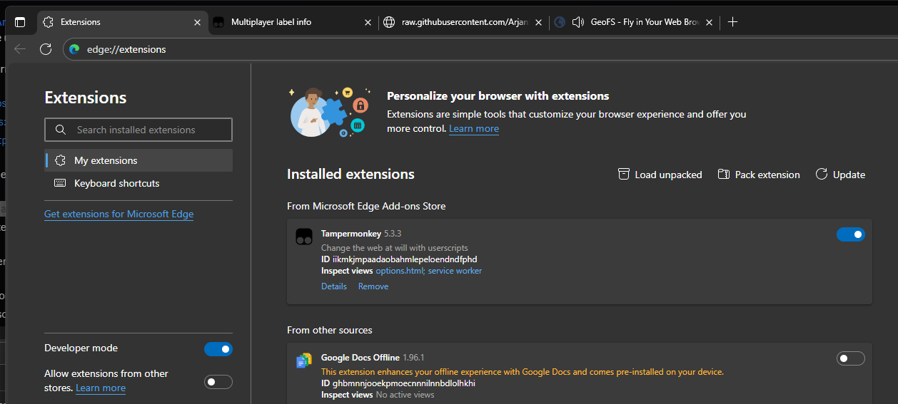

Pin Tampermonkey so you can access it easily:

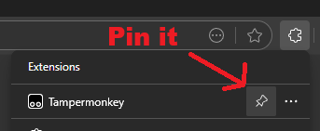

### Install the Livery Selector

Go to the [Releases page of the Livery Selector](https://github.com/kolos26/GEOFS-LiverySelector/releases), and click on the latest version of the user.js file (fe. “[GeoFS-LiverySelector-V3.3.1.user.js](https://github.com/kolos26/GEOFS-LiverySelector/releases/download/v3.3.1/GeoFS-LiverySelector-V3.3.1.user.js)"). TamperMonkey will open and ask you if you want to install the script:

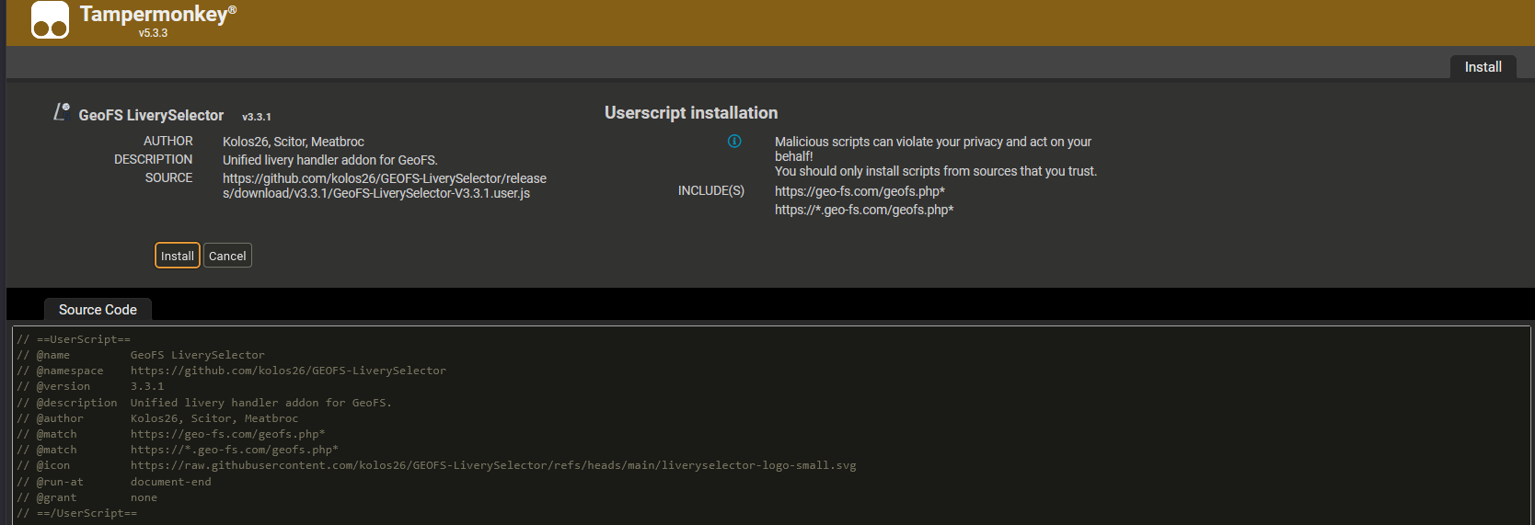

Click *Install*.

Refresh the Geo-FS page. You should now see the Livery Selector:

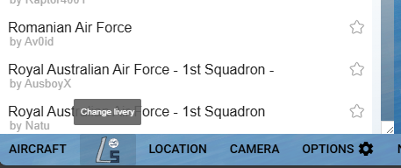

If you don’t see it, make sure that Tampermonkey is allowed to execute scripts.

### Add our Virtual Airline

The GeoFS Blue Angels have their own Virtual Airline, that allows us to each have our own airplane with our name on it, and our number:

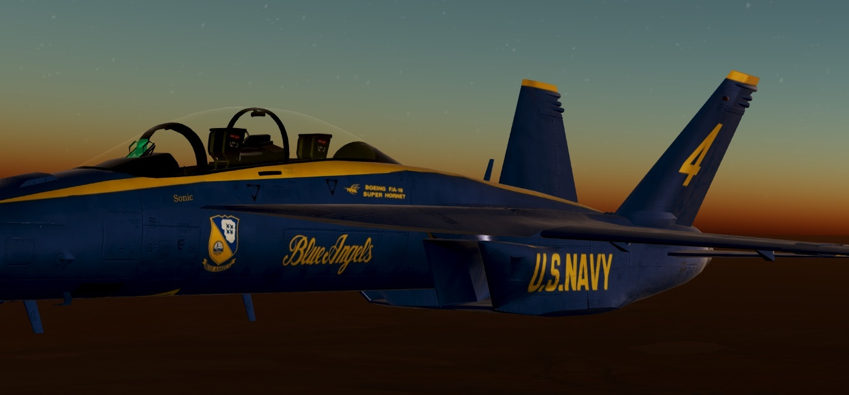

To choose your airplane, choose the F-18, open the Livery Selector and scroll down to Virtual Airlines. Click the green “Add Airline” button and paste in the following URL:

<https://raw.githubusercontent.com/ArjanKw/GeoFS-BlueAngels/refs/heads/main/airline.json>

You should now see our Airline, and you’ll be able to choose your livery:

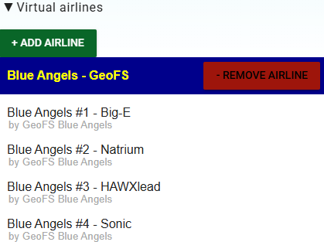

### Other scripts

[Go to our Github page](https://github.com/ArjanKw/GeoFS-BlueAngels) to install other relevant scripts, that could help you in your flying. For example the script that shows the distance and speed of other airplanes. That will allow you to join the formation more easily:

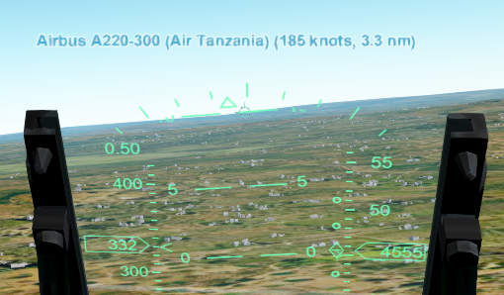

# Communication

Discord voice is the best form of communication, as it allows uninterrupted communication without the need to type (or having to monitor the chat while flying). But by default, we use chat. Make sure you have the Chat Fix script installed, so you can talk easily via chat.

In this manual, all communication **“Is marked like this”**.

By default only #1 communicates, and the others only respond when asked a question, or when an order can’t be executed. If you don’t respond to commands, it means you agree. To acknowledge explicitly, you can simply say your number.

For example, #1 announces **“Ready?”**. #2 responds with **“2”**. If you are not ready, answer **“Negative”** or **“neg”**. If you can’t execute an order, reply with **“Unable”**.

**Important:** when you type, you’re not able to fly with the same level of precision. So we focus on short communication that gets the point across, instead of trying to mimic real-world chatter. You also don’t need to mention your number, as the chat already mentions your Blue Angels number.

**Important #2:** when we fly together, make sure your name contains your Blue Angels number, in this format: “<Name>[BlueAngels<NR>]”. For example: “Natrium[BlueAngels2]”. You’re not required to use this name when not flying with us.

Strict communication is key in important phases of the flight (take off, parade formations, stunts and landing). The rules can be eased when flying in a loose formation during cruise.

# Our training location

The Blue Angels are based at the Pensacola airport (KNPA). We conduct our training flights at KNPA:

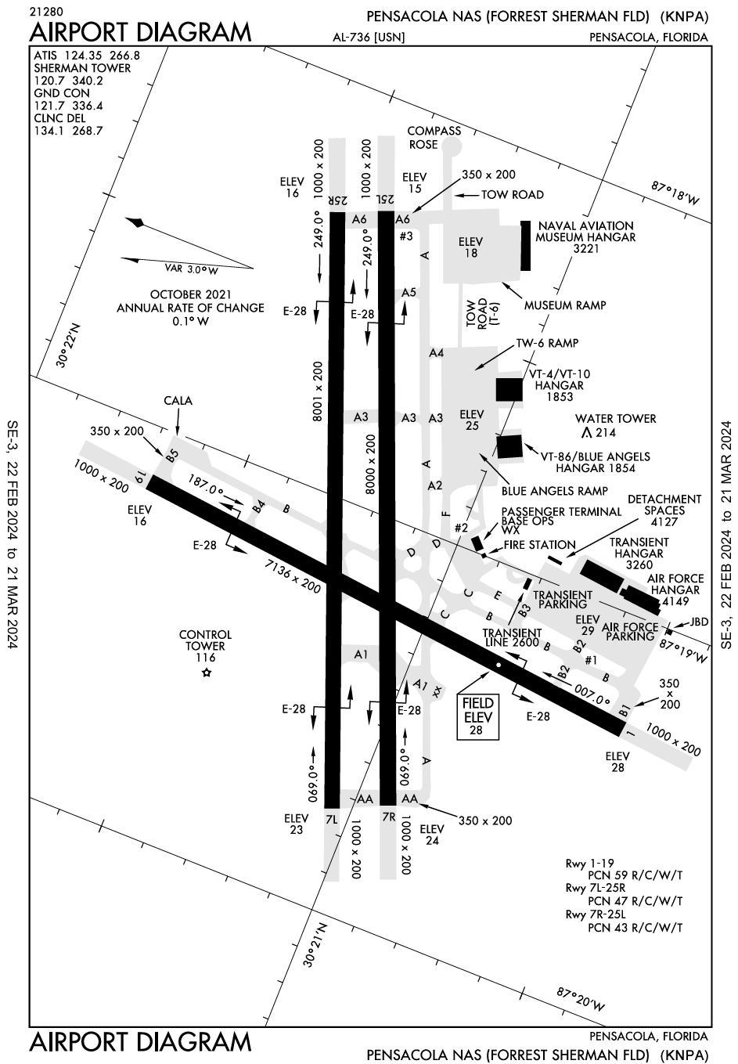

## Parking

We park in front of the Blue Angels Hangar:

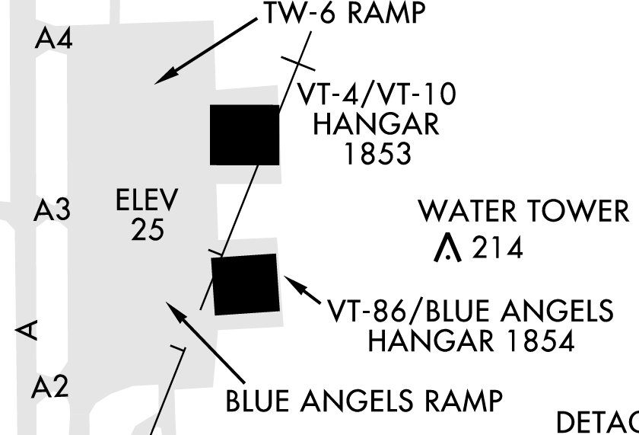

We park in order:

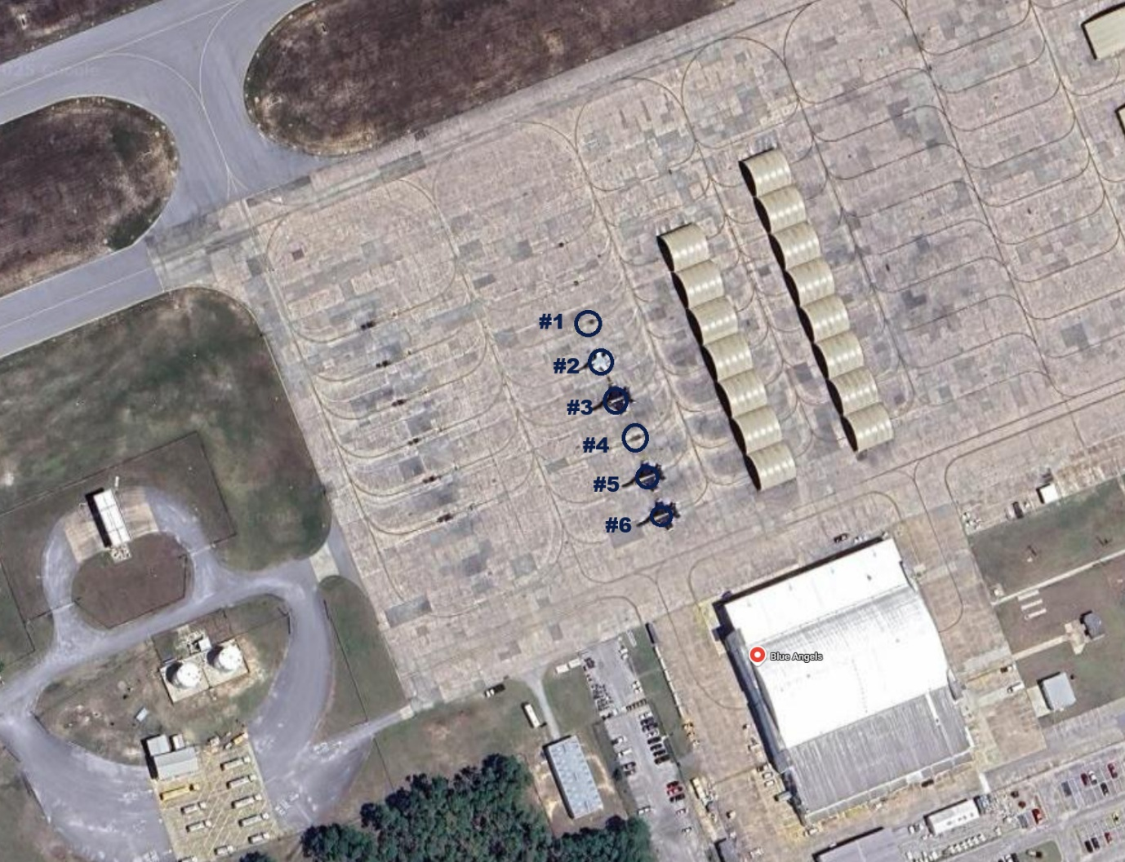

# Basic maneuvers

## Before taxi

Wait until all aircraft are parked in the correct position. Engines should be off. #1 announces **“Start engines”**, waits until engine is spooled up and asks **“Ready?”**, upon which all flight members say their flight number if they are ready, in order. #2: **“2”**, #3: **“3”**, and so on.

## Taxiing

#1 starts to taxi, followed by #2, #3 and so on. We taxi by default in close formation, alternating left and right:

|  |  |
| --- | --- |
|  |  |

If the taxiway is small, #1 can decide to change to a line-astern (trail) formation (everyone behind each other). This will be communicated in the briefing, or during the taxi (**“Taxi in trail”**).

At KNPA we follow this route, unless wind condition necessitates another runway for departure:

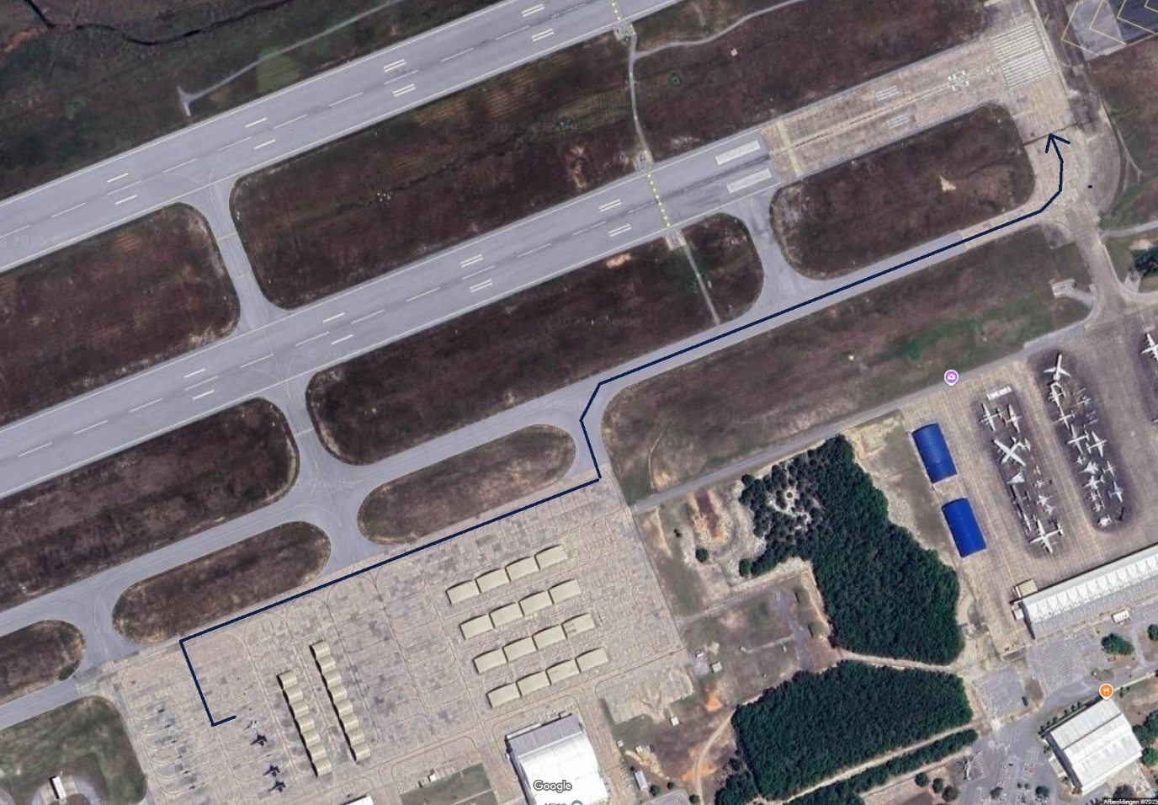

We hold short at the runway threshold for final checks and an ATC clearance. Everyone sets Flaps 1. #1 communicates with the tower (if active) and asks the flight members if they are ready (**“Flaps 1. Ready?”**), upon which all flight members say their flight number if they are ready, in order. #2: **“2”**, #3: **“3”**, and so on. If all members are ready and the flight is cleared for take-off, #1 announces **“Enter runway”** and we line up on the runway.

## Take-off

We line up on the runway in the same positions as how we taxi.

#1 should roll forward more than usual to allow the entire team to line up on the runway.

**Important:** when doing an airshow, #5 and #6 will take off separately. They will wait next to the runway, until the main formation starts rolling, after which they will line up. When training formation flying, we take off all together.

The #1 issues **“Get Ready”**. All flight members spool up their engines to 30% (on keyboard: press 2) while applying brakes. #1 issues **“GO”**, upon which everyone releases their brake and increases power to 90% (on keyboard: press 8). This is done so that there is room for everyone to catch up if they lag.

At 175 knots #1 pulls back on the stick gently. As soon as we lift off each pilot raises their gear and drifts to their position in the formation. Unless briefed otherwise that will be the default formation depending on the number of players in the formation (see the next chapter). For example:

|  |  |
| --- | --- |
| **Diamond formation (4-ship)** | **Delta formation (6-ship)** |

We will always fly in a close parade formation during the takeoff and climb.

#1 goes straight in a 5 degrees nose up attitude while building up speed over the runway, flying manually. As soon as we reach the end of the runway he pulls back to a 15 degrees nose up attitude. Everyone raises their flaps at that moment for a seamless transition. Unless briefed otherwise we fly straight until reaching cruising altitude.

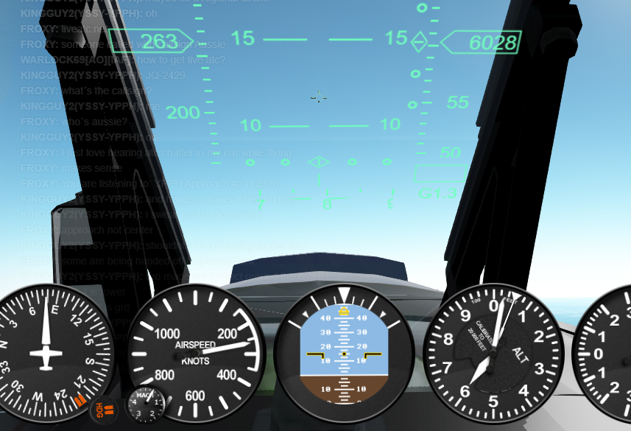

1,000 feet below the cruising altitude, #1 starts to level off smoothly, still flying manually. #1 lets the speed increase until we reach cruising speed and eases up the throttle gently to keep that speed. For cruising, #1 engages the autopilot at the moment he flies stable.

**Important:** every flight member should know this procedure by heart, so he/she is able to anticipate the next move of #1. #1 will not communicate every change (like flaps up, level off or the acceleration stop when we reach cruising speed), as #1 is busy on flying the maneuver with precision.

## Cruising

The flight lead announces all changes in flight before they are performed. When communicating via chat, #1 gives the other pilots at least 5 seconds, before starting the change. He issues **“GO”**, and starts the change after that. With voice communication the **“GO”** can be given sooner.

In chat communication, we keep the communication brief.

* **“Right h270”** 🡪 Turn right heading 270.
* **“CP2”** or **“Checkpoint 2”**  or **“Checkpoint TRAIL”** 🡪Turn to the specified checkpoint and climb/descend to the target altitude.
* **“Turn right”** 🡪 Turn right.
* **“Align runway”** 🡪 Align our flight with the briefed runway.
* **“Align runway 15L”** 🡪 Align with a specific runway.
* **“Align runway right”** 🡪 Align with the right runway in front of us.
* **“1000 ft”** 🡪 Ascend/descend to 1,000 feet.
* **“300 kn”** 🡪 Increase/decrease speed to 300 knots.

Combine commands if you want to execute them simultaneously. Fe. “Align runway, 200 ft, 300 kn”

## Landing

### Overhead Break landing

When coming in to land all the aircraft join in one formation. In short we land by pitching up shortly to clear the formation, then break by turning downwind (one after the other). As the Blue Angels always end with the Delta formation, they call it the “Delta pitch-up break”. We call it the “Overhead break”, the broader term used in naval aviation for this kind of landing. As this formation is always followed by a landing, we don’t need to communicate that internally (unless we need to inform ATC).

### Approach

#1 starts by announcing **“Overhead Break Right/Left”**. With right or left everyone knows which way to turn. If the runway isn’t briefed, add that as well. Fe. **“Overhead Break Right 27R”**.

**Note to #1:** Try to land on a runway that is on the edge of the airport, so that when we break we don’t fly our circuit over the airport itself, but next to it. In the example below, break right:

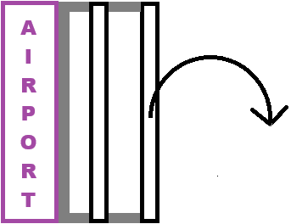

Next #1 announces **“Align runway”**, followed by **“GO”**. This not only means that we will align, but also that we will set up the speed and altitude at the same time. Smooth transitions for #1 are of the essence.

|  |  |  |
| --- | --- | --- |
|  | **Novice** | **Experienced** |
| **Entry speed** | 300 knots | 420 knots |
| **Entry altitude** | 200’ AGL | 200’ AGL |

#1 disengages the autopilot while aligning if it was turned on. His focus is to fly straight over the runway at the briefed speed and altitude.

**IMPORTANT**: Below 1000 feet we fly Above Ground Level, not Above Sea Level:

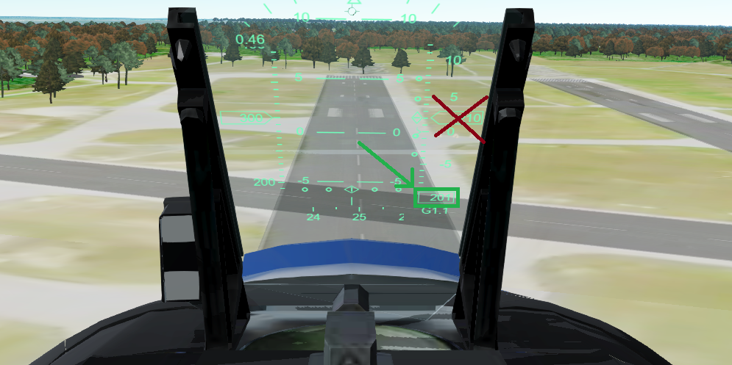  
Do not use the default altimeter, as we can’t reset it.

### The break

This is the maneuver according to the Maneuver Manual of the Blue Angels:

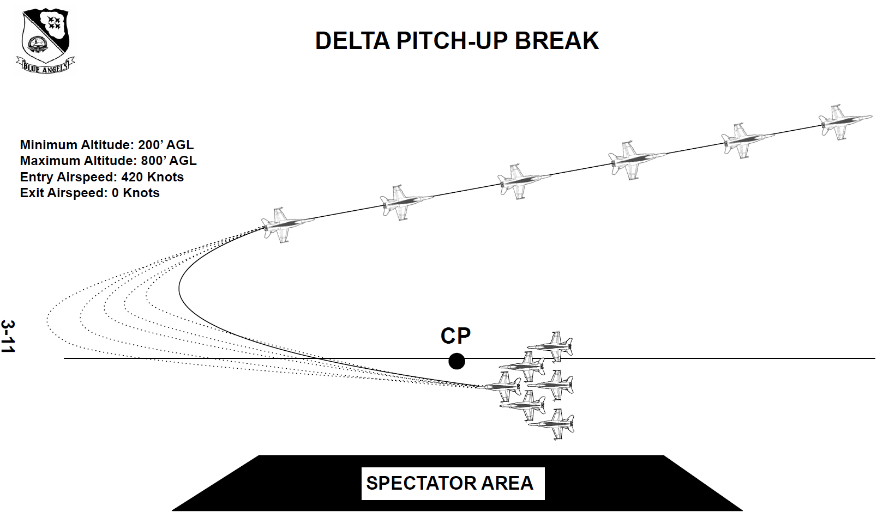

**MANEUVER: Ingressing at 200’ on the 500’ line from crowd left or right. Each aircraft pitches out of the formation with approximately 2 second spacing, and turns away from the crowd to downwind, and configures for landing at 15-18’ intervals.**

These are our break parameters:

|  |  |  |
| --- | --- | --- |
|  | **Novice** | **Experienced** |
| **Break every** | 4 seconds | 2 seconds (#1 turns tighter than #2 and so on, so that enough separation is achieved) |
| **Max altitude / altitude downwind** | 1000’ AGL | 800’ AGL |
| **Max G’s** | 4 | 4 |
| **Speed downwind** | 200 knots | 200 knots |

**Turn**  
#1 breaks out first, followed by #2, then #3 and so on. We start with a spacing of 4 seconds in between each break. When proficient, we decrease the spacing to 2 seconds.

Pitch up shortly (just a minor pitch up to clear the formation), then bank right, wings almost vertical and start the turn while pulling the throttle to idle and extending the speed brake. Pull max 4G and level the wings when flying downwind.

**Downwind**We don’t fly parallel to the runway, but slightly away from it, so we can come in with a gentle turn. Decrease the speed to 200, then close the speedbrakes, extend the gears and go Flaps 1. Keep flying straight and level until the runway is around 30 degrees behind you.

**Base leg / final**We don’t fly a separate base leg and final. Instead we fly in a continuous turn, until we align with the runway. The closer to the runway you start the turn, the more difficult this will be. Flying with a joystick will be really beneficial, as you can use the hat button to keep looking at the runway, while flying the plane.

Start the turn and at the same time lower the flaps to Flaps 2, and start your descent at the same time. Look at the runway PAPI lights to see if you’re high or low. Let your speed decrease as well to around 160. Do a final check: speedbrakes retracted, gears down, flaps 2.

### The landing

Aim for the [aiming point markings](https://pilotinstitute.com/runway-markings-explained/) and land exactly there. **Do not flare!** The speed upon landing should be between 140 and 150.

**Landing navy-style**In the US Navy, pilots don’t flare for a soft landing. Instead, they aim for a specific point on the runway, and ‘drive down’ their plane until they are on the ground. ‘Buttering’ landings involves flaring just above the runway and makes you unable to land on an exact spot.

The Blue Angels are part of the US Navy. Landing is thus performed in navy-style.Examples of Blue Angels landing in Navy style:

* [Blue Angels Landings #1](https://youtu.be/iCgl_M663s0?si=3g-uF-QGTxCvyFrk&t=106)
* [Blue Angels Landings #2](https://youtu.be/sfkDD3n75xM?si=96_SBMCD0knYdymm&t=164)
* [This article shows a gif of Blue Angels landing without flare](https://www.twz.com/how-blue-angels-pulled-off-landing-all-their-a-4-skyhawks-at-once)

|  |  |
| --- | --- |
|  |  |
|  |  |

Why do they do this? To showcase the capabilities of the pilot to land on an exact spot, the capabilities of the airplane to withstand these landings and to remain proficient in these types of landings. This is why navy pilots in general land navy-style, even when they land on civilian airports.

# Formations

Learn the following formations by name and remember your place in the formation.

We have two ways of flying our formation: in parade (extremely close and demanding), and loose (maintaining more space, just like formations in the military). The parade formation is used during the airshow, the loose formation is used during cruising.

The #1 can issue the following command:

* **“Go parade”** 🡪Move into parade position
* **“Go loose”** 🡪 Go to default cruising position.
* **“Close up”** 🡪 Close up the formation.
* **“Loosen up”** 🡪 Increase the formation distance.

## Wingman formation

Fly this when **“Go wingman”** is announced by #1. This is the default formation when flying with two airplanes.

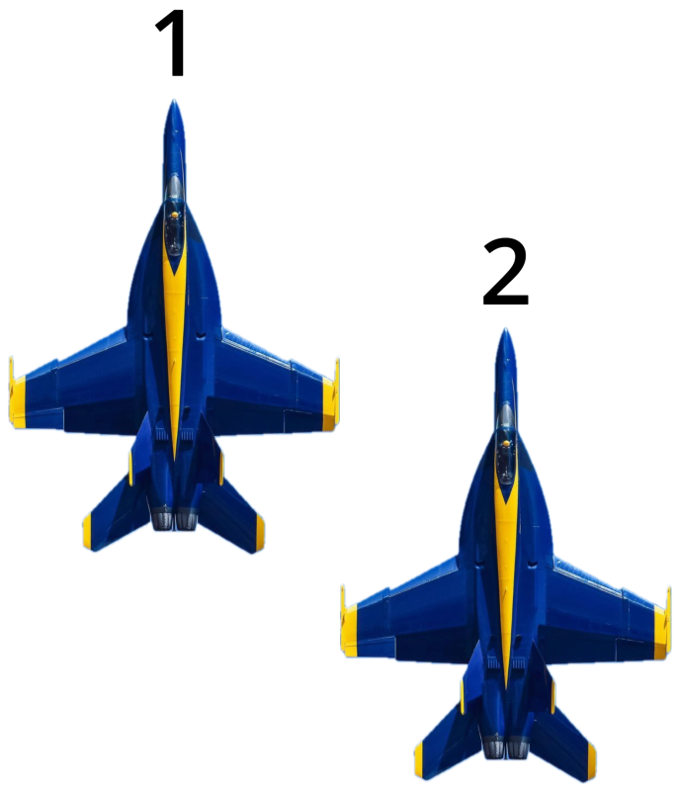

## Diamond formation

Fly this when **“Go diamond”** is announced by #1. This is our default 4-ship formation.

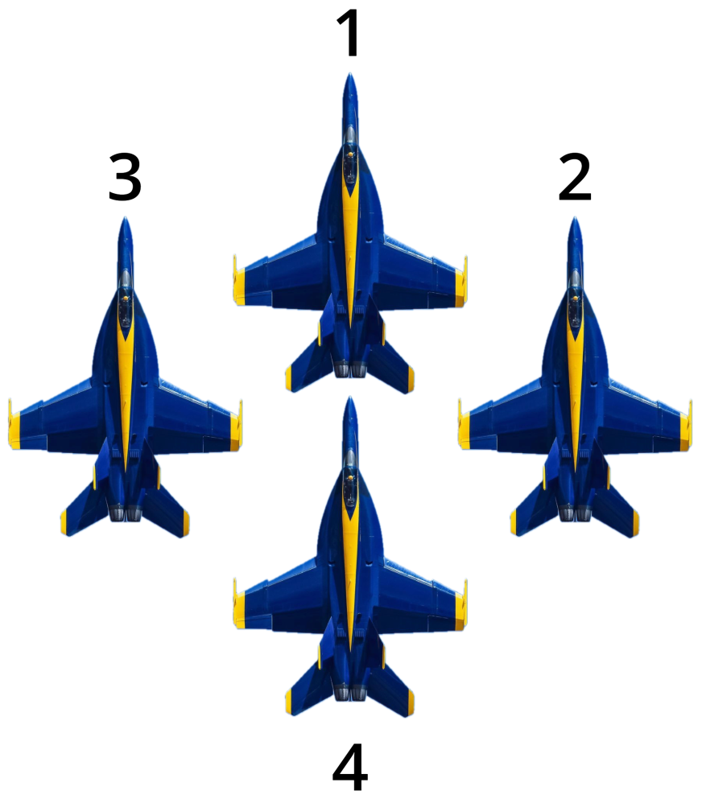

## Vic formation

Fly this when **“Go vic”** is announced by #1. This is our default 3-ship and 5-ship formation. Also called a V formation.

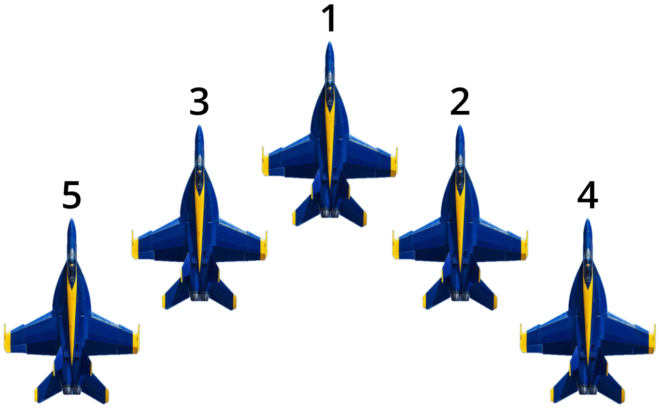

## Delta formation

Fly this when **“Go delta”** is announced by #1. This is our default 6-ship formation and is basically the Vic formation, with #6 added in the center.

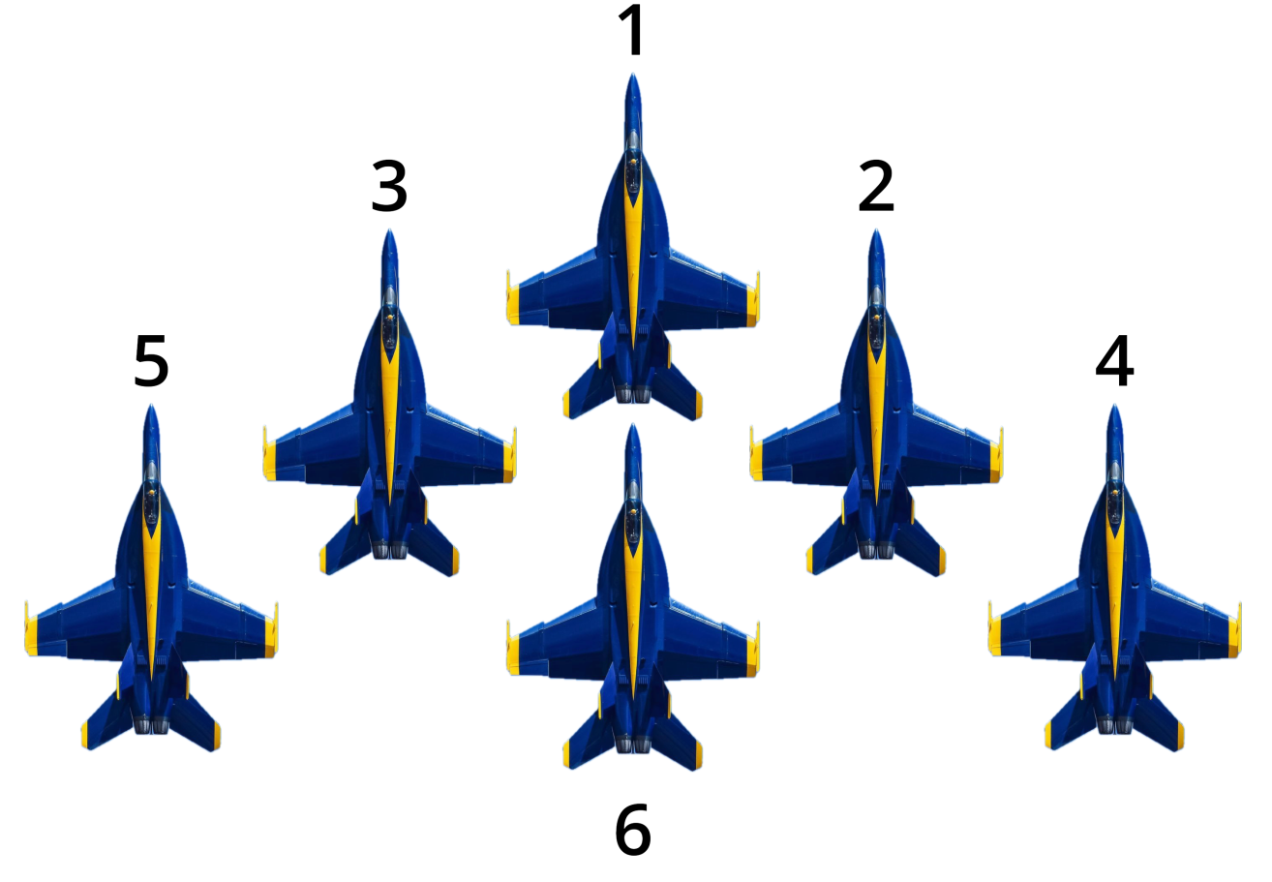

## Echelon formation

Fly this when **“Go echelon”** is announced by #1. By default we fly on the right side of #1, unless **“Go echelon left”** is announced:

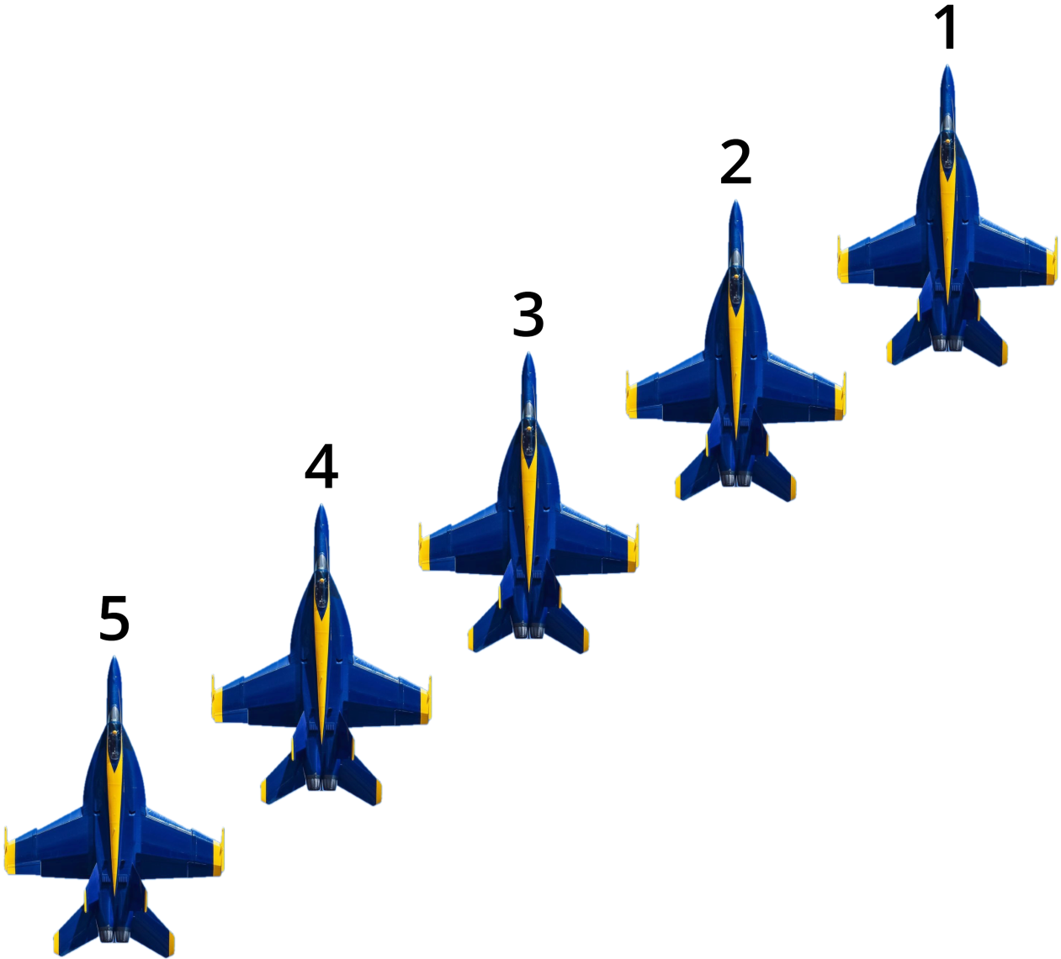

## Line abreast formation

Fly this when **“Go line”** is announced by #1. By default we fly on the right side of #1, unless **“Go line left”** is announced.

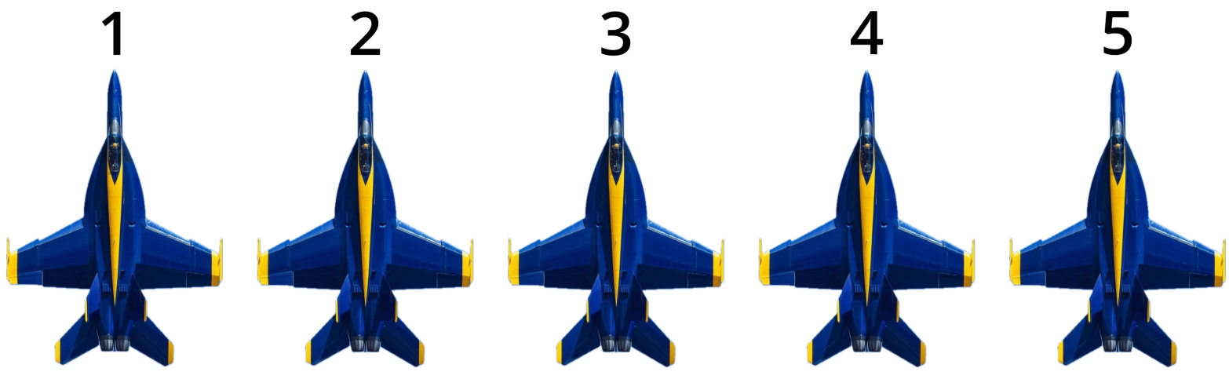

## Line astern (trail) formation

Fly this when **“Go trail”** is announced by #1. Fly slightly below the plane in front of you, as in the real world this is needed to prevent turbulence.

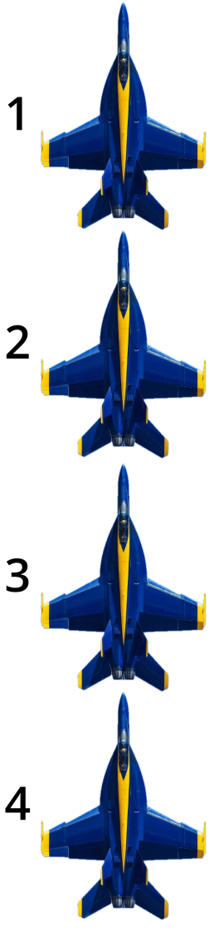

## Finger four formation

Fly this when **“Go finger four”** is announced by #1. By default we fly a left hand finger four formation, unless **“Go finger four right”** is announced. The finger four is often used in combat, as it can be split easily in two elements (#1 and #2 / #3 and #4).

|  |  |
| --- | --- |
| **Left hand Finger Four (default)** | **Right hand Finger Four** |
|  |  |

# Acrobatics

We perform the following acrobatics.

## Looping

…

## Missing man formation

# Flight Plans

Here you can find flight plans that we use to train. This will save us time preparing flights.

Import the flight plan into your navigation by downloading the *Flight Plans* folder from our Github: Go to [our Releases page](https://github.com/ArjanKw/GeoFS-BlueAngels/releases) and download the latest release.

In Geo-FS, press ‘N’ to open the Navigation bar. Click on “FLIGHT PLAN” to open the Flight Plan Panel:

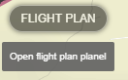

Now click on the folder icon to load the flight plan:

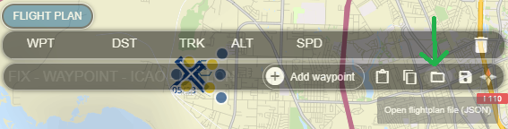

Load the correct flight plan, for example “1-Pilot-Checkride.json” for the Pilot Check ride. You’ll now see the route, with the desired altitude and speed.

## Pilot Check Ride

Demonstrate your pilot skills using the pilot check ride. This flight is normally conducted with one instructor and a trainee. We will follow all procedures as outlined in this manual.

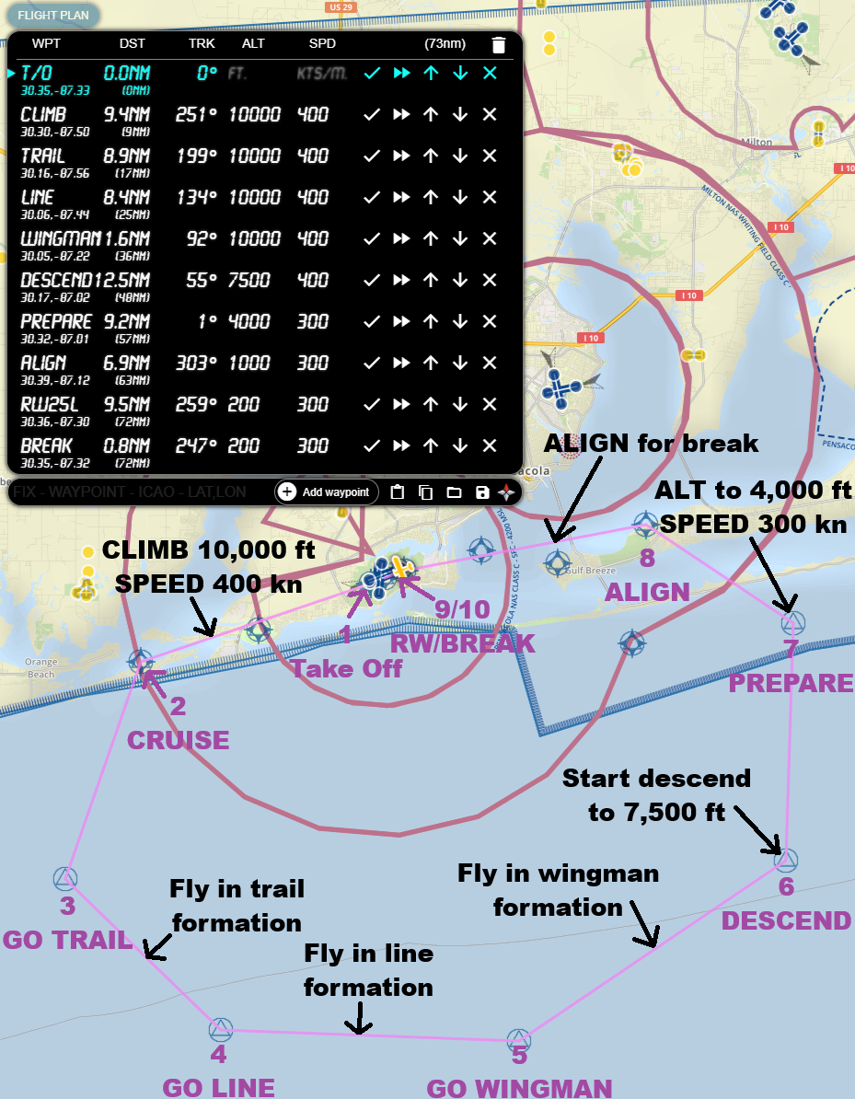**Taxi**  
Taxi from the Blue Angels parking to runway 25L.

**Checkpoint 1 – T/O**Take-off from runway 25L (checkpoint 1). Demonstrate that you can fly in parade formation while climbing and while levelling off at 10,000 feet (ASL) with 400 knots as our cruising speed. We should arrive in a stable formation when we reach checkpoint 2.

**Checkpoint 2 – CRUISE**When arriving at checkpoint 2, #1 will call **“CP3”** and **“GO”** to start the turn left to checkpoint 3. Stay in the same formation, so you can showcase that you can keep formation during turns.

**Checkpoint 3 – GO TRAIL**Arriving at checkpoint 3 we turn left to checkpoint 4 (**“CP4”**). #1 will announce **“Go trail”**. #2 should go into trail formation.

**Checkpoint 4 – GO LINE**Arriving at checkpoint 4 we turn left to checkpoint 5 (**“CP5”**). #1 will announce **“Go line”**. #2 should go into line formation.

**Checkpoint 5 – GO WINGMAN**Arriving at checkpoint 5 we turn left to checkpoint 6 (**“CP6”**). #1 will announce **“Go wingman”**. #2 should return to the wingman formation.

**Checkpoint 6 – DESCEND**Arriving at checkpoint 6 we turn left to checkpoint 7 (**“CP7”**). This will both mean a left turn **and** descending to 7,500 feet.

**Checkpoint 7 – PREPARE**Arriving at checkpoint 7 we turn left to checkpoint 8 (**“CP8”**). This will both mean a left turn **and** descending to 4,000 feet, while reducing speed to 300 knots. #1 will prepare you for the landing by calling out “Overhead Break Left 25L”

**Checkpoint 8 – ALIGN**Just before reaching checkpoint 8, #1 will announce **“ALIGN”**. This means we will align to the runway at 300 knots, while descending to 200 feet **Above Ground Level (!)**.

**Checkpoint 9 / 10 – RW/BREAK**Checkpoint 9 is right over the start of the runway. We should be in a close parade formation. When we are halfway, #1 announces “Break” and breaks left. 4 seconds later #2 should break (see our Landing maneuver).

**Landing**Demonstrate that you can land in navy style on the aiming point. Taxi to the end of the runway and follow #1 to the Blue Angels hangar. Park your jet on the same spot as where you started and turn off your engine.

Basic Maneuvers

|  |  |  |
| --- | --- | --- |
| Taxi | | |
| **Default (taxi in pairs)** | | “Start taxi” |
| **Small taxi ways** | | “Taxi in trail” |
| Before takeoff  Stop before entering runway. | | |
| **Set** | | Flaps 1 |
| **Check** | | “Flaps 1. Ready?” |
| **Confirm (in order)** | | “2” … “3” … etc. |
| **Start to enter runway** | | “Enter runway” |
| Takeoff | | |
| **Position** | In pairs of two | |
| **Break** | Engage | |
| **Throttle** | 30% (press 2) | |
| **Final check** | “Ready?” | |
| **Confirm (in order)** | “2” … “3” … etc. | |
| **Start takeoff roll** | “GO” | |
|  | Break: release | |
|  | Throttle: 90% (press 8) | |
| **Rotate** | 175 knots | |
|  | Gear: up | |
|  | 5 degrees over runway | |
| **Climb** | Flaps: up | |
|  | 15 degrees nose up | |

Formations

|  |  |
| --- | --- |
| Proximity | |
| **Parade** | “Go parade” |
| **Loose** | “Go loose” |
| **Close up formation** | “Close up” |
| **Loosen formation** | “Loosen up” |
| Formation | |
| **Wingman** – default 2 ship | “Go Wingman” |
| **Diamond** – default 4 ship  Vic with 4 in center | “Go Diamond” |
| **Vic** – Default 3/5 ship  V with 4 on right, 5 left. | “Go Vic” |
| **Delta** – default 6 ship  Vic with 6 in center | “Go Delta” |
| **Echelon** – Default right  Diagonal line formation | “Go Echelon (left)” |
| **Line abreast** – Default right  Next to each other in line | “Go line” |
| **Line astern / Trail**  Behind each other | “Go trail” |
| **Finger four** – default left  Like 4 fingers on your hand | “Go finger four (right)” |
| ... | |
|  |  |
|  |  |